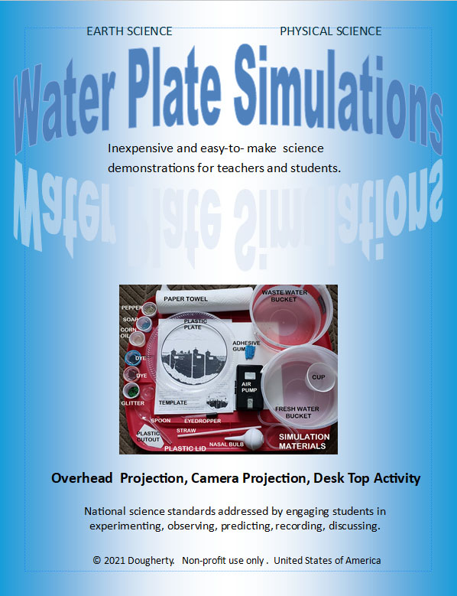

“WATER PLATE” SCIENCE SIMULATIONS

Free science lesson booklet download. Non-profit educational purposes only.
https://desklabsllc.com
© 2014 Dougherty Revised © 2021 Dougherty

CONTENTS

Introduction to Plate-Template Simulations………….. 1

This booklet includes short utube video links for kit operation and lesson objectives.

Longshore Currents
EXAMPLE
https://youtu.be/PEg7RgmtN8Q
Water Cycle, Groundwater, Pollution (perimeter flow). 5
Water Cycle, Groundwater, Pollution (center flow)….. 6
Heat Transfer, Winds, High/Low Pressure Systems… 7
Air Masses, Fronts, High/Low Pressure Systems……… 8
Polar Vortex, Air Masses, Jet Stream…………………… 9
Cold, Warm, Occluded, and Stationary Fronts………… 10
North Atlantic Ocean Circulation………………………… 11
North Pacific Ocean Circulation…………………………. 12
Sea-Land Breezes………………………………………… 13
Plate Tectonics, Drift, Divergent/Convergent Zones…… 14.
Rock Cycle…………………………………………………. 15
Geothermal Events, Groundwater, Geysers…………… 16
Rip Current, Rip Tide……………………………………… 17
Longshore Currents, Erosion/Deposition……………….. 18
Indoor Air Currents, Airborne Germs…………………… 19
Outdoor Air currents, Airborne Germs…………………… 20
Orbit and Gravity……………………………………………. 21
Extensions…………………………………………………. 22.

INTRODUCTION

- WHY
- Connect scientific principles (Physical Science) to natural processes (Earth Science).
- Addresses many Next Generation Science Standards (NGSS) and Science, Technology,
Engineering, Mathematics (STEM) national goals.
NGSS: simulation model will help identify patterns, interactions, connections, transfer of
energy, stability, change, etc. STEM: simulation model acts like a “wind tunnel” where
various “hands-on” investigations promote inquiry, critical thinking, problem solving analysis.
- WHAT
Class demonstrations and/or student projects simulate real-world events.
- WHO
A teacher or a student.
- WHEN
Introduce a new science concept, reinforce objective with tactical and visual component, show “cause and effect” relationships… every action, has a reaction
- WHERE
Simulations are for classroom projection systems, classroom table activities, or home projects.
- HOW
Use simulation kit/model to target grade-level goals.

1.

Simulation Kit Supplies (Refer to photo)
Most materials are household/school items: clear plastic plate (about 7” dia.); food coloring dye (red & blue), vegetable oil (in containers with lids); eyedropper; glitter; plastic spoon; plastic water & waste buckets; plastic water cup; paper towels. Optional: air pump (battery or 110 volt) with connecting tubing, rubber band, flex straw, and adhesive gum.

Simulation Concept
Common everyday observable natural events are observed in the confines of a clear plastic plate with water. Basic fluid dynamics (i.e liquid and gas motion) demonstrate Bernoulli’s principals of movement: fast moving particles create low pressure (fewer particles) and slow moving particles create high pressure (more particles). In sum: movement is to a less crowed area. Adapt lessons to grade-level goals.

1. Presentation Video link of two basic presentation methods: https://youtu.be/uy4Imn779P0

Copy selected event templates, pages 5-22.
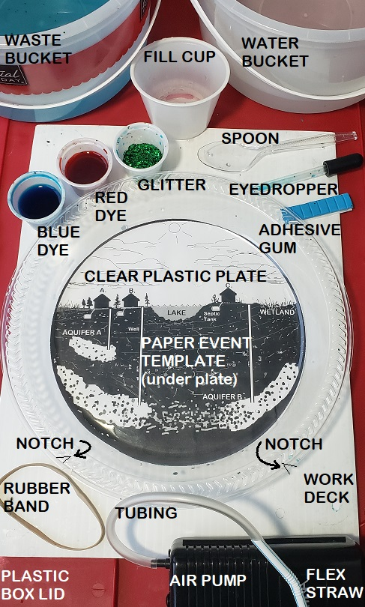
Modify to grade-level goals/performance expectations

Teacher Activity
- Decide how you want students to learn objective:
- Class demonstration, class activity, and/or home
activity. Select Motion and Medium tools (p.3).
- “Air Pump” method (Motion, p.3) is recommended
for classroom projection demonstrations.
- Suggestion: create a student note-taking template
copy.

Student Activity
- Make copy of selected template. Select Motion and
Medium tools (p.3).
- If using “Eyedropper” method refer to Motion, p. 3.
- Set up kit on water proof deck (i.e. plastic storage lid).
- Research concepts listed on template. Carry out
simulation.
- Record observations. Draw-label/photo/video.
Present it.

2. Set-up
Level the presentation
surface. Place clear
plastic plate on selected
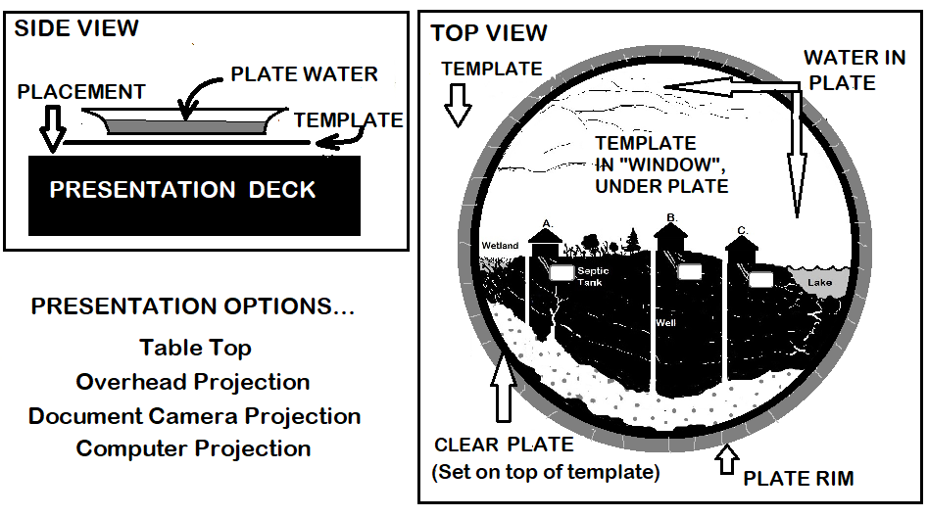
template (Fig. 1). Fill plate
to about ¼” water depth.
Level by moving adhesive
gum around perimeter using
thickness for depth gauge
and shim accordingly.

Non-pump assembly Fig. 1

Pump assembly p. 3, Fig. 4

Fig. 1

2.

-Photo (right) shows layout of materials—not all are
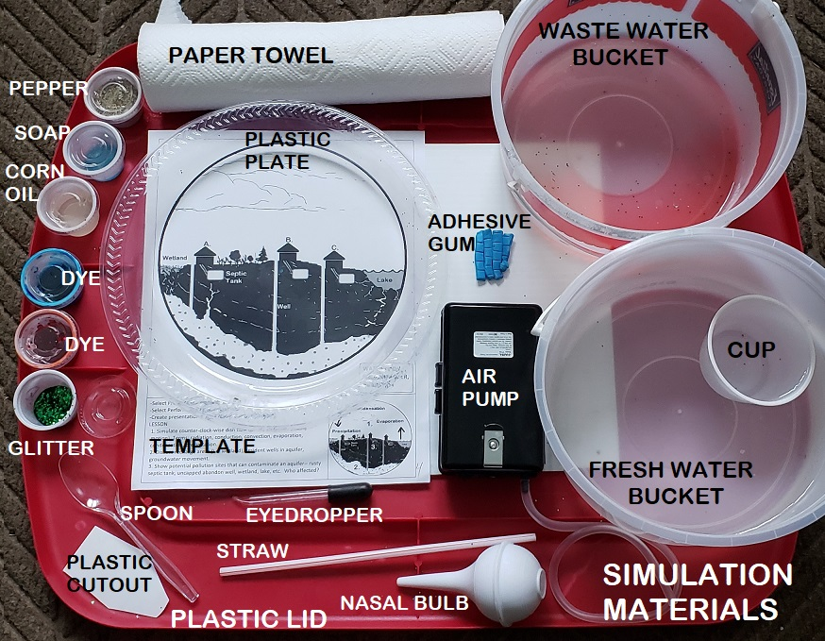
needed for basic operation (refer to Event Templates).

3. Motion (creating/extending currents)
-Experiment with various ways to move water with
air (eyedropper, straw, pump, etc.) or a paddle
(push, pull, stir, snake, sweep). Tap for ripples
and/or waves.
-Test various air outlet locations (Fig. 2): Move along
location “A”, hold outlet in water, on water, above
water (B), set angle near horizontal to vertical (C).
Concept: new current will return to starting point.
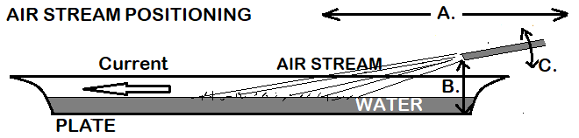

Fig. 2

EYEDROPPER Method (inject dye, water, or air)
- Use eyedropper or spoon as a paddle to
start current in desired direction.
- Boost current direction by squeezing part or entire eyedropper bulb. Experiment with flow by using slow to fast pulsating action (Fig. 3), injecting air or water (dye/clear).
C . Deposit a drop of dye or draw a line with dye in target area. Gently purge fluid to
Fig. 3
slowly nudge dye plume in desired direction. Repeat.
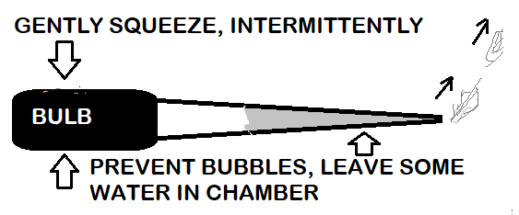

AIR PUMP Method (battery or 110 v with panel switch)
Aquarium air pump method is primarily for class
demonstrations. Placement options: Figures 4, 5, & 6.
- Cut rubber band notches on rim of
Fig. 4
clear plastic plate. Stretch thick
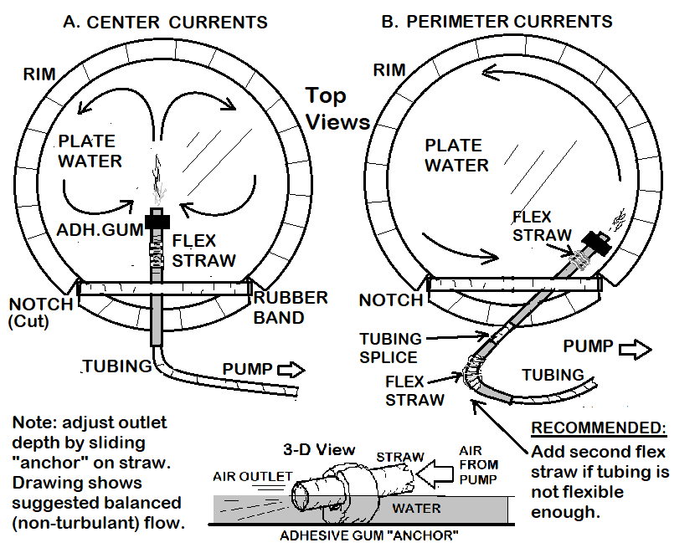
rubber band between notches—
creates friction to hold flex straw.
B. Level plate deck. Position template.
C. Set plate on template, add ¼” water.
D. Insert tubing into flex straw (angled
cuts) widening straw mouth with
pencil. Add short second flex straw if
pump tubing not very flexible.
E. Wrap a piece of adhesive gum (or
clay around outlet of flex straw for
anchor. Adhesive gum prop (Fig. 6)
helps if straw has short reach—lowers
air outlet--changes current velocity.
F. Connect tubing to pump after
unwinding tubing kinks--get it to lay
at desired air outlet angle on plate.
Continue to adjust air outlet angle by
moving plate, pump, and/or flex straw.
G. Plate orientation: rubber band on
the bottom is “6:00” (Fig. 4); “3:00”
Fig. 5
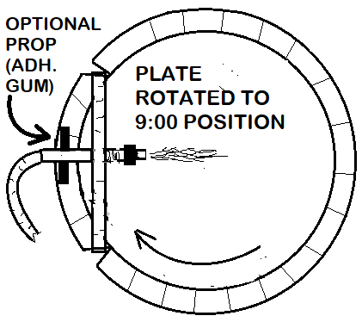
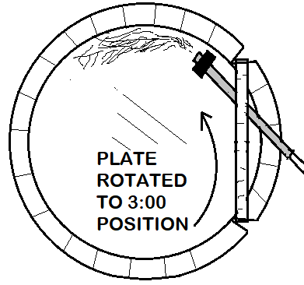
Fig. 5); “9:00” (Fig. 5).
.
Other Motion Options…
-Spin plate to create current--place bead of
adhesive gum under center of plate. Hold rim,
rotate plate.
-Create barrier(s): stop, deflect, reflect--lay strips
of adhesive gum (or clay) in selected areas.
Fig. 6
3.

4. Medium (tracing/highlighting)
Diluted food coloring dye and glitter.
Test diluted dye—it should float. Sprinkle glitter to release surface tension between particles.
Options: vegetable oil, pieces of black transparency cut-outs, pepper, plastic lid, etc.
Suggestion: red dye is warm air, magma, pollution. Blue dye is cold air, water (rain, lake, etc.).
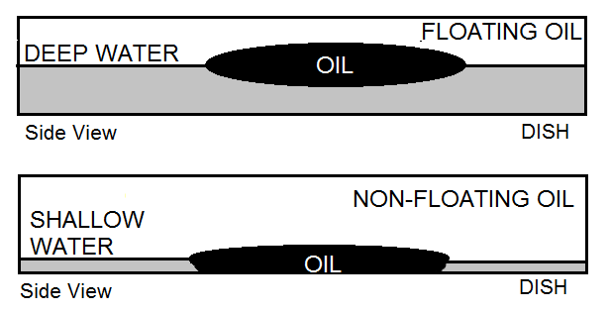
Floating Oil : Gently place (with spoon)
oil in deeper water (Fig. 7).
Activity idea: polar air mass “blob” moves
from arctic region to North America (p.9).
Non-Floating Oil: Drop oil in shallow water,
so it sticks to bottom of plate. Experiment
with flow patterns around it.
Fig. 7

5. Troubleshooting
- Check to see if plate is level - Dilute dye so it floats, not sinks.
- Change placement of air outlet - Change water depth.
- Apply concept: slow current ‘feeds” fast current

6. Practice Activities
Set-up: plate, water, eyedropper, dye, glitter, pump (optional), p. 22 template (optional). Practice various methods used to get a particular current…

- Generate water currents with air outlet (eyedropper or pump) or paddle-like methods using dye and glitter to trace resulting currents. Observe high pressure SLOW current “feeding” low pressure FAST current. Use concept to direct current flow to desired area on plate. Suggestion: select an Event Template. Experiment with it. Note directions provided at base.
2. Create waves with paddle action (i.e. spoon).
3. Create ripples by dropping an object.
4. Use plastic cut-outs (transparencies, plastic plate/lid, etc.) to highlight or trace fluid motion.

STUDENT PROJECTS

Simulation templates (p. 5-p.22) and extension ideas (below and p.22) offer a starting point for grade-level student science projects…

- Continental Drift. Trace North America and Africa (p.22) from transparent plastic plate or
transparency. Cut out pieces. Place in water (“mantle”). Continent crust floats (less dense).

- Shape and Flow. Experiment with currents moving around shapes. Highlight areas of fast/slow
current with dye/glitter. Fabricate different shapes (p.22) with adhesive gum, clay, etc.

- Bernoulli’s principle and efficient design-- challenge students to make a streamline car, boat, plane wing, etc. Record observations on template copy (p. 22).

- Cells. Observe blood stream and cell movements: (i.e white cells surrounding bacteria) using
vegetable oil---nudge, split, and/or rotate blob.

- Compass: secure magnetized pin to a small cut-out transparency using adhesive gum/clay
and/or float iron filings on a piece plastic (move with magnet).

- Density concepts: concentrated vs diluted dye, ice cube with blue dye, bubbles, fizz, etc.

- Surface tension—place a drop soap on floating pepper/glitter, etc. (i.e. explosion, etc.).

- Create new ideas with templates (p. 22) that reflect everyday common air flow events.

4.

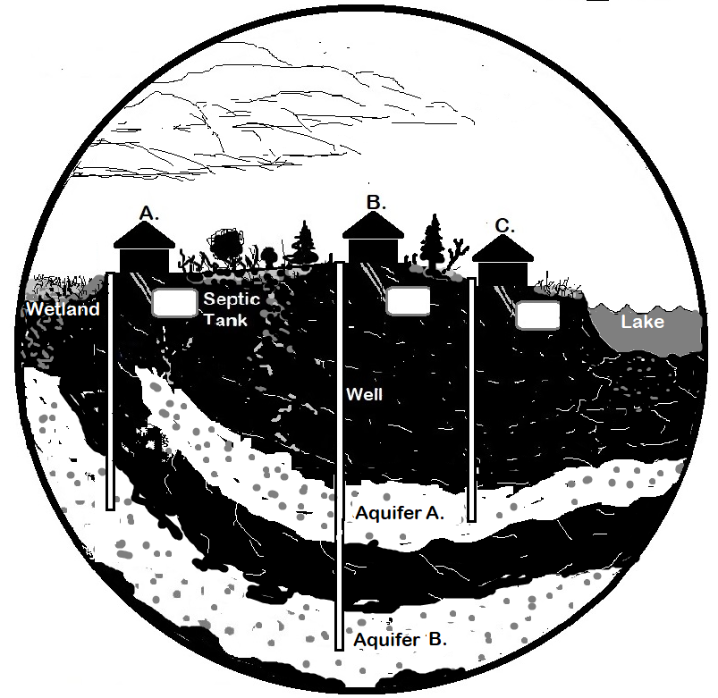

Video link
https://youtu.be/Dd_dyoy_DiI

A. WATER CYCLE,
GROUNDWATER

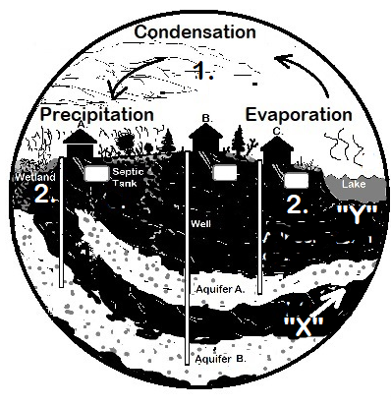
-Select presentation set-up options and performance expectations pages 1-4.
-Supplement with resource material: NGSS: ESS 2-5,2-6, 3-3,3-4; PS 1-4, 3-5
-Create presentation & note taking template copies using this page.
WATER CYCE, GROUNDWATER LESSON (Perimeter Current)
- 1. Blue dye traces evaporation, condensation, precipitation, recharge areas.
- Eyedropper: Motion A, B, C, p. 3. Inject blue dye at “Y”, then at “X”.
- Pump: refer to p. 3, Fig 4B or Fig. 5.
- 2. Groundwater movement: draw a red dye line (with eyedropper) to show potential
- contamination sources in aquifers: wetland, rusty septic tank, uncapped
- abandon well, fertilizers in porous ground, lake pollutants, resident wells.
- Terms: radiation, conduction, convection, evaporation, condensation,
- precipitation, recharge, permeable, porous, aquifer, groundwater, wetland.

5.

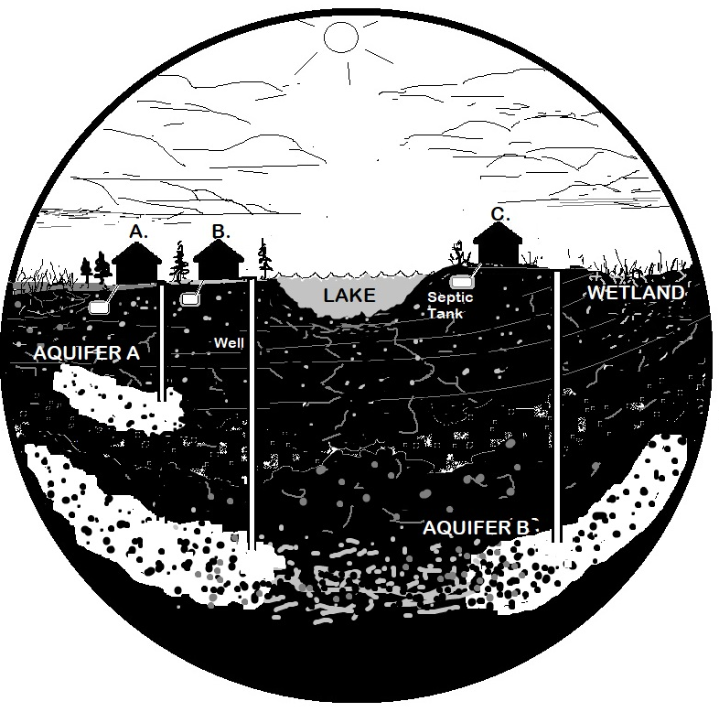

B. WATER CYCLE,
GROUNDWATER
Video link
https://youtu.be/uy4Imn779P0

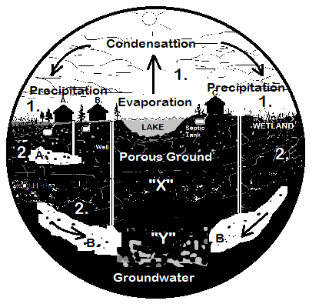
-Select presentation set-up options and performance expectations pages 1-4.
-Supplement with resource material: NGSS: ESS 2-5,2-6, 3-3,3-4; PS 1-4, 3-5
-Create presentation & note taking template copies using this page.
WATER CYCE LESSON (Center Current)
- 1. Blue dye traces evaporation, condensation, precipitation, recharge areas.
Eyedropper: Motion A, B, C, p. 3. Inject blue dye at “X”, then at “Y”.
Pump: refer to p. 3, Fig 4A.
2. Groundwater movement: draw a red dye line (eyedropper) to show
potential contamination sources in aquifers wetland, rusty septic tank,
uncapped abandon well, fertilizers in porous ground, lake side pollutants
into resident wells.
- Terms: radiation, conduction, convection, evaporation, condensation,
- precipitation, recharge, permeable, porous, aquifer, groundwater, wetland.

6.

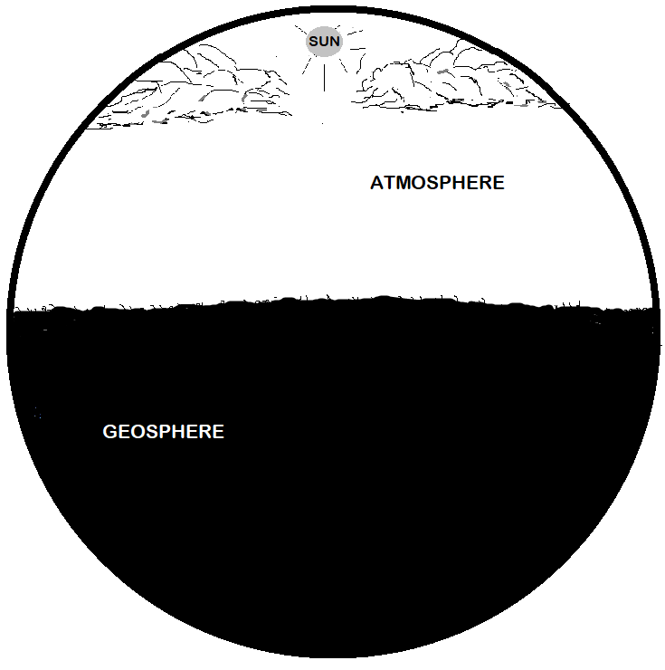

Video link
https://youtu.be/9qFDIoIi2Pk

HEAT TRANSFER, TRADE WINDS

-Select presentation and performance expectations pages 1-4.
-Supplement with resource material. NGSS: ESS 2-5,2-6; PS 3-5
-Create presentation & note taking copies using this page.
HEAT TRANSFER LESSON
1. Simulate radiation, conduction, convection and resulting “wind”.
Eyedropper: Motion A, B, C, p. 3. Inject red dye at “X.
Pump: refer to p. 3, Fig 4A.
2. Highlight “wind” with dye. Discuss 30 degree north/south latitude air flow
- back to equator, Trade Winds, Sub Tropical Jet, Hadley Cell, Horse
- Latitudes, Doldrums, water cycle, high and low pressure cells.

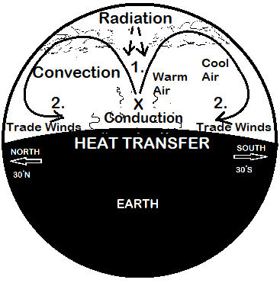

7.

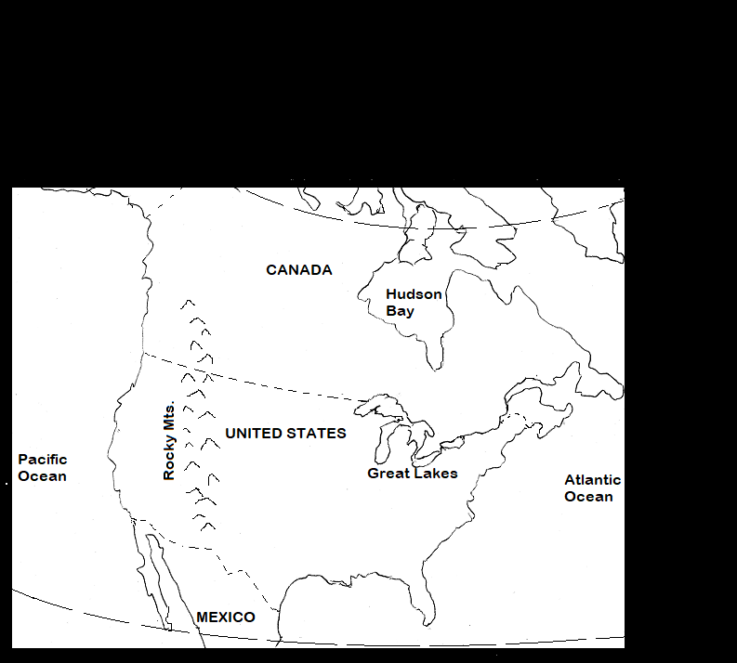

Video link
https://youtu.be/E_e6sU0unys

AIR MASSES,
FRONTS

-Select presentation and performance expectations pages 1-4.
-Supplement with resource material: NGSS: ESS 2-5,2-6; 3-2; PS3-5
-Create presentation & note taking template copies using this page.

AIR MASS, FRONTS, POLAR VORTEX LESSON
1. Simulate continental and/or maritime polar air mass movement.
Eyedropper: Motion A, B, C, p. 2. Inject blue dye at #1.
Pump: refer to p. 3, Fig 5. Discuss weather, climate, frontal
boundaries, jet stream, seasonal polar vortex influence.
2. Gently inject puff of red dye at #2 to simulate warm air mass, Tornado
Alley—shoe cold, warm and occluded frontal boundaries. Note:
black frame highlights main area to view. Slide dish over template to
shift current (jet stream) north or south over targeted area.

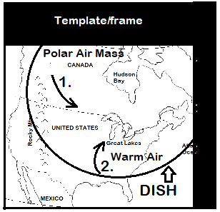

8.

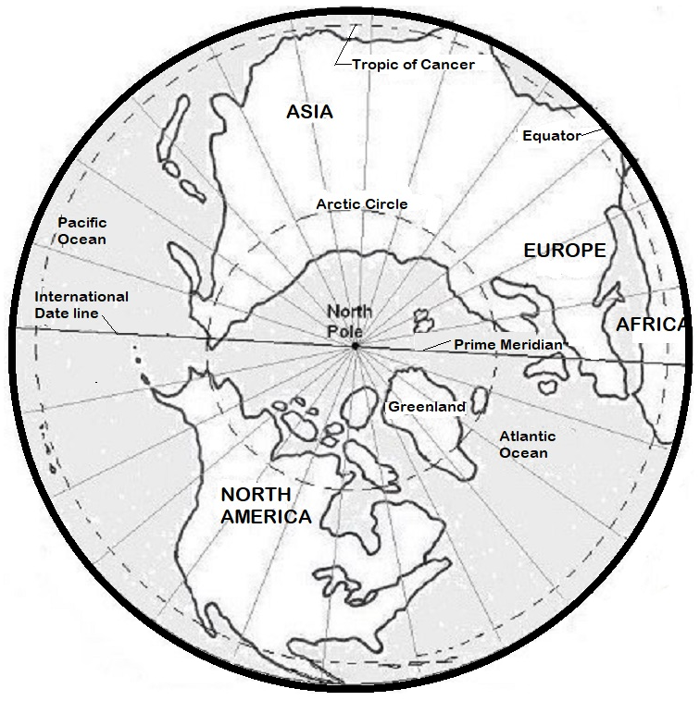

POLAR VORTEX,
COLD AIR MASS
Video link
https://youtu.be/9RPAkfU95dk

-Select presentation and performance expectations pages 1-4.
-Supplement with resource material: NGSS: ESS 2-5,2-6; 3-2; PS3-5
-Create presentation & note taking template copies using this page.

POLAR VORTEX, AIR MASS LESSON
- Simulate a Polar Vortex where strong jet stream usually contains arctic air in region. Add extra water to plate. Gently set one or two spoons of vegetable oil on surface of plate water (p. 4, Medium). Use spoon or eyedropper to slowly pull, push, rotate, or separate the “blob”. Experiment with pump outlet locations.
- Simulate Polar Vortex and/or polar air mass with a weak jet stream allowing more southerly flow. Split main oil mass into one or two smaller moving- rotating blobs to illustrate cold marine/continental air mass moving across the North American continent and resulting weather/climate variables.
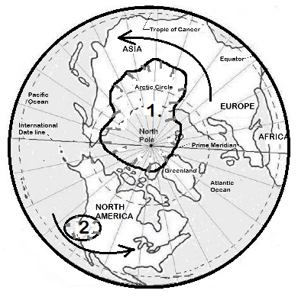

9.

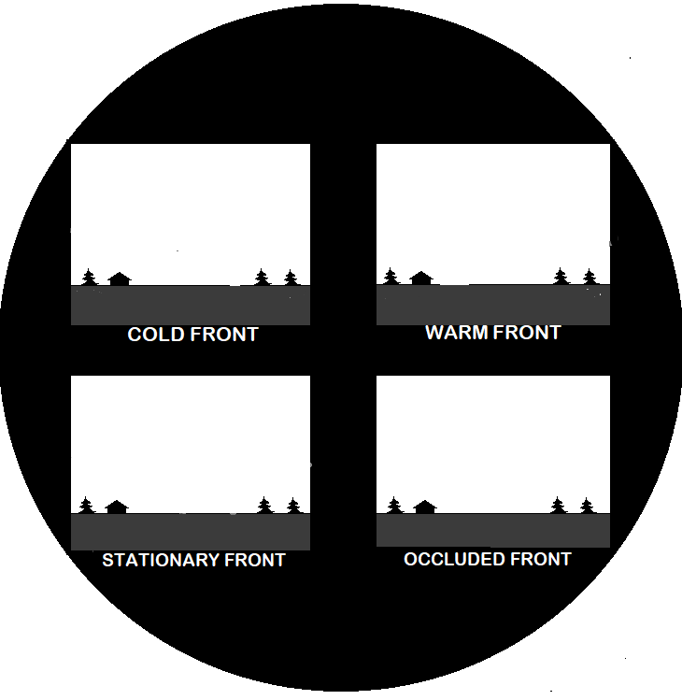

FRONTS
-Select presentation and performance expectations pages 1-4.
-Supplement with resource material. NGSS: ESS 2-5,2-6; PS 3-5
-Create presentation & note taking copies using this page.

COLD, WARM, STATIONARY, OCCLUDED FRONTS LESSON
- Simulate dense Cold Front colliding with less dense warm air. Use eye dropper to paint cold air blue and then very gently purge eyedropper red dye in direction of arrow.
- Simulate Warm Front overtaking cold front. Use eyedropper to paint cold air blue and very gently purge red dye in direction of arrow.
- Simulate Stationary Front. Use eyedropper to paint cold air blue and warm air red. Note: deposit drops in still water.
- Simulate Occluded Front. Place a drop of blue dye & a drop red dye near center with eyedropper. Use eyedropper to swirl dyes--merge/mix
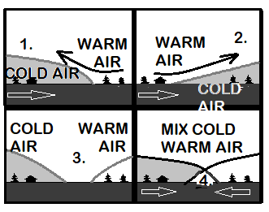

10.

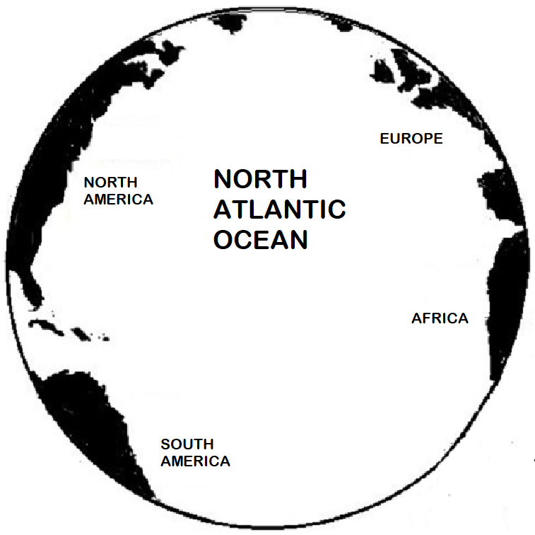

ATLANTIC OCEAN CIRCULATION
Video link
https://youtu.be/vl1IFcTnxUk

-Select presentation and performance expectations pages 1-4.
-Supplement with resource material. NGSS: ESS 2-4,2-6
-Create presentation & note taking copies using this page.

ATLANTIC OCEAN CIRCULATION LESSON
- Simulate ocean circulation with clock-wise movement of water.
Eyedropper: Motion A, B, C, p. 3. Inject red dye at #1
Pump: refer to p. 3, Fig 4B position straw opposite side.
Add red dye to stream heading up along North American coast
(Gulf Stream). When circulation reaches north area add blue dye
with eyedropper. Discuss circulation pattern. Terms: Trade
winds, Coriolis effect, Gulf Stream, temperature, salinity, density,
migration patterns, etc.
- Discuss formation of Sargasso Sea in the center, as ocean
current circulates around it, associated marine life.

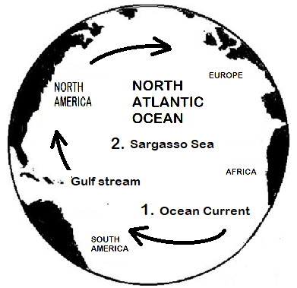

11.

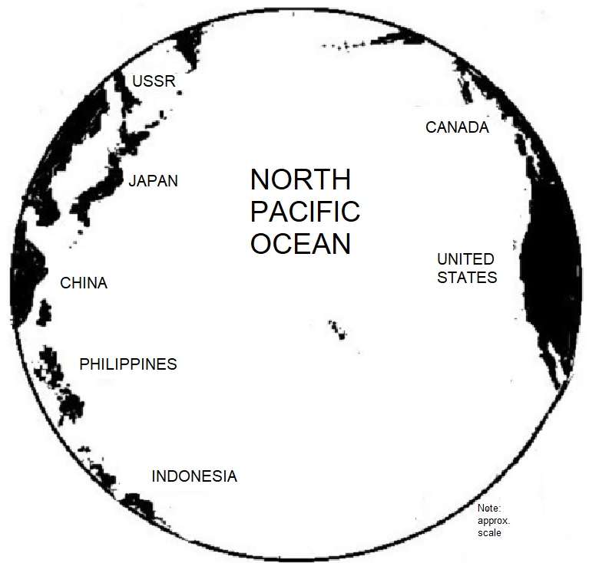

PACIFIC OCEAN
CIRCULATION

-Select presentation and performance expectations pages 1-4.
-Supplement with resource material. NGSS: ESS 2-4,2-6
-Create presentation & note taking copies using this page.

PACIFIC OCEAN CIRCULATION LESSON
1. Simulate North Equatorial Current with clock-wise movement of water.
Eyedropper: Motion A, B, C, p. 3. Inject red dye at #1
Pump: refer to p. 3, Fig 4B position straw opposite side.
- Add blue dye to currents travelling to North American coast creating the California Current. Discuss climate related to this cooler current.
- Simulate ocean “gyre” circulation currents that are known to trap floating trash (i.e. plastics) using glitter to highlight inner ocean currents, pollution. Discuss effects on marine life, human life. Terms: Trade Winds, Coriolis effect, Gulf Stream, temperature, salinity, density, migration patterns, etc.

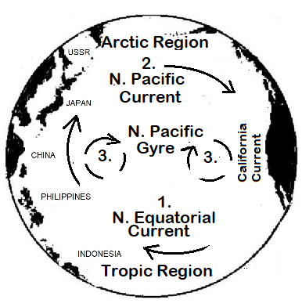

12.

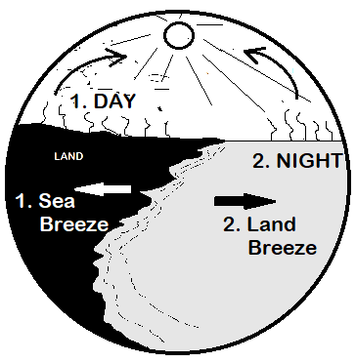
SEA AND LAND BREEZES
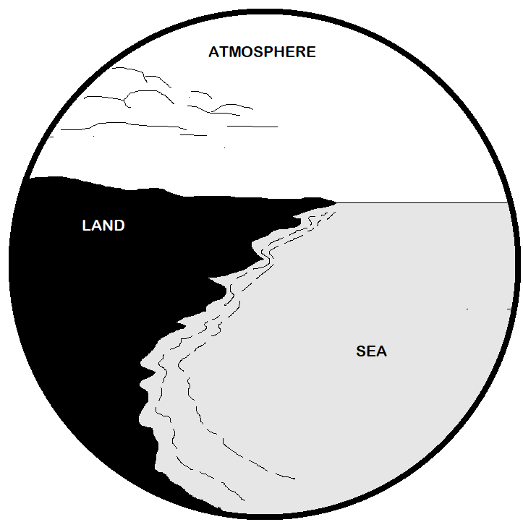
-Select presentation and performance expectations pages 1-4.
-Supplement with resource material. NGSS: ESS 2-4,2-6; PS 3-5
-Create presentation & note taking copies using this page.
SEA-LAND BREEZES LESSON
- Simulate on-shore “sea breeze”: day time radiation, conduction, and
Convection. Discuss rising warm air, sinking cool air, and breezes, Trade winds, El Nino, etc.
Eyedropper: Motion A,B,C, p. 3. Sweep spoon clock-wise, inject red
dye (#1 at arrow), observe returning dye, “wind”.
Pump: refer to p. 3, Fig 4B, position straw opposite side.
- Simulate an off-shore warm water night time “land breeze”. Reverse
#1 procedures with dye at #2. Discuss how winds affect climate (i.e. breezes, Trade Wind, La Nina, etc.)

13.

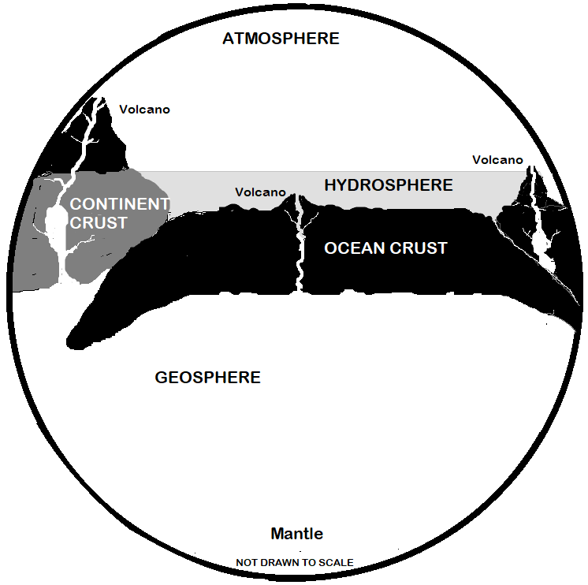

Video link
https://youtu.be/T8l7vyZrajY

Plate Tectonics
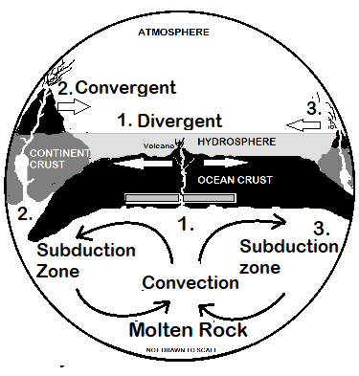
-Select presentation and performance expectations pages 1-4.
-Supplement with resource material. NGSS: ESS 1-4,2-1,2-2,3-1; PS 3-5
-Create presentation & note taking copies using this page.
PLATE TECTONICS LESSON
1.Simulate magma rising in mantle and rift zone divergent boundary.
Eyedropper: Motion A,B,C, p. 3. Pump: refer to p. 3, 4A.
Lay 2” strip of adhesive gum on Ocean Crust to divert current. Inject red dye upward from bottom. Discuss convection current, divergent plate boundary. Add drop of dye in vent/rift volcano-- underwater eruption.
2. Highlight volcano eruption where ocean crust collides with continent crust.
Use with red dye. Discuss convergent boundaries, continental drift, plate t
tectonics.
3. Inject dye at site #3, subduction zone. Discuss ocean-ocean
convergent boundary, island arc, earthquakes, etc. Note: friction at
subduction zones create volcanic activity.

14.

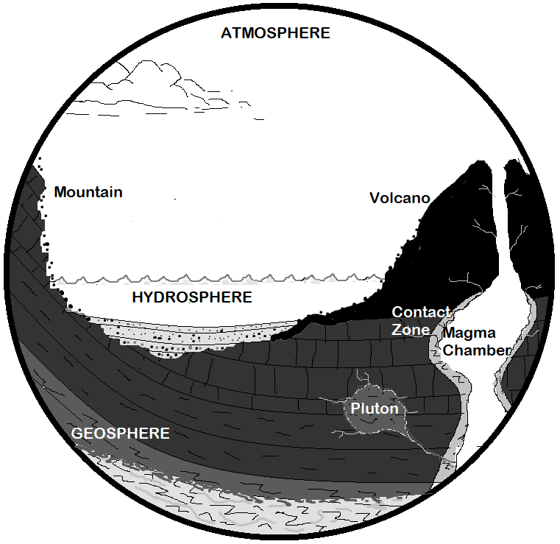
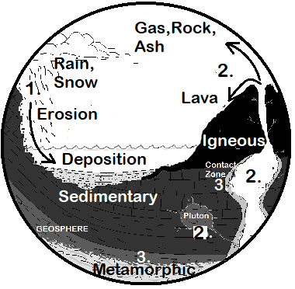
ROCK CYCLE
-Select presentation and performance expectations pages 1-4.
-Supplement with resource material. NGSS: ESS 1-4,2-1,2-2,3-1; PS 3-5
-Create presentation & note taking copies using this page.
ROCK CYCLE LESSON
1. Simulates sedimentary rock formation use glitter to illustrate weathering.
Eyedropper: Motion A, B, C, p. 3. Pump: refer to p. 3, 4B.
Sprinkle glitter in cloud area (precipitation). Motion also shows erosion process
on mountain side, deposition of sediments. Discuss: water cycle, weathering,
erosion, deposition, ice wedging, sediment transport.
2. Simulates igneous rock. Paint magma chamber with red dye. Purge eyedropper
(or add dye to pump flow) toward volcano neck. Discuss eruption, cooling
process (lava, pluton, etc.). Terms: vents, veins, sills, dikes, magma chamber,
ash, gas, lava, pipe/neck, pluton, intrusive/extrusive rocks, molten rock.
3. Use eyedropper (pump off) to paint red dye in basement rock and contact
zone areas to simulate metamorphic rocks. Discuss heat-pressure by burial,
convergent plate boundary and contact zone (i.e next to a hot burner).

15.

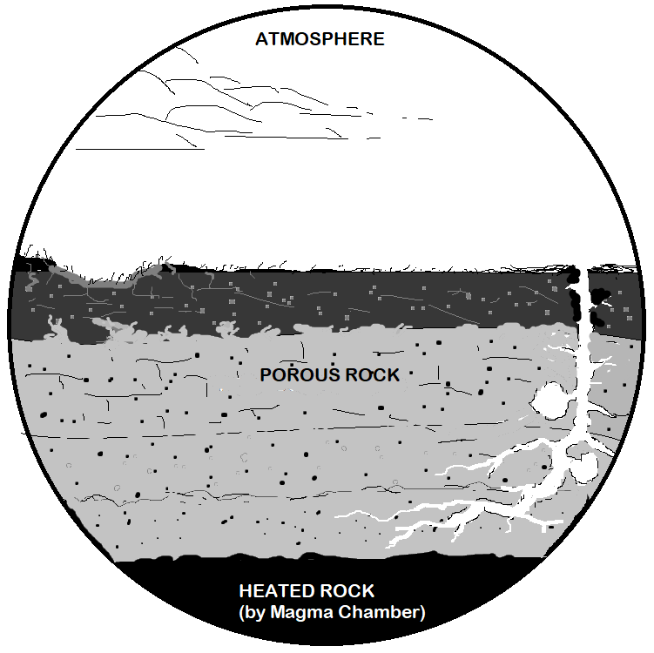

GEOTHERMAL
EVENTS

-Select presentation and performance expectations pages 1-4.
-Supplement with resource material. NGSS: ESS 2-2,2-4, 3-1; PS 1-2,3-5
-Create presentation & note taking copies using this page.

GEOTHERMAL GROUNDWATER LESSON (conceptual drawing)
1 Simulate rain water (blue dye) seeping through porous ground
filling underground porous rock layers, reservoirs (caverns) in
limestone rock, etc.
Eyedropper: Motion A, B, C, p. 3
Pump: refer to p. 3, 4B.
2. Simulate groundwater getting heated (red dye), turning into
steam, erupting through vent as geyser. Discuss hot spring,
fumarole, mud pot, other types of geothermal heating.

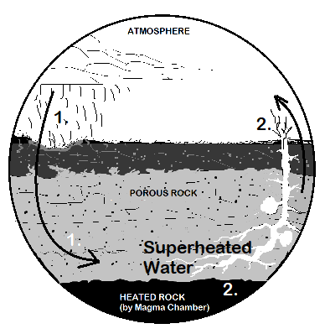

16.

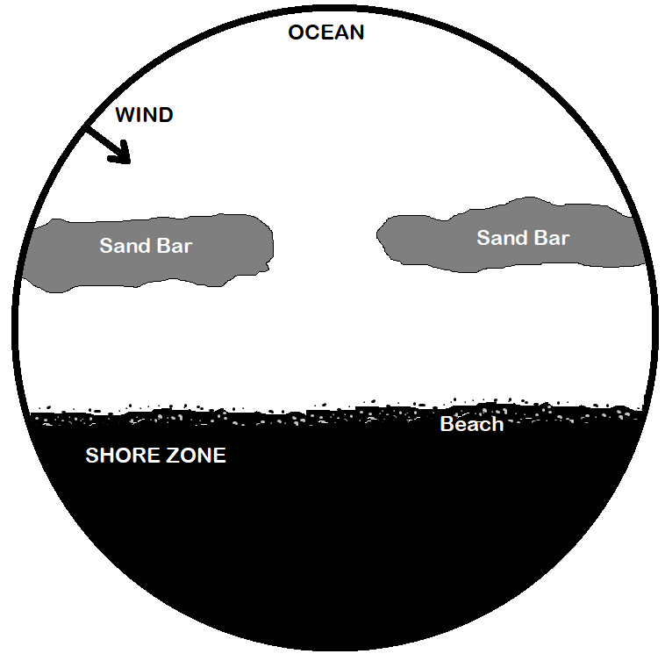

Video link
https://youtu.be/m5Nt6_rrUsc

RIP CURRENT

-Select presentation and performance expectations pages 1-4.
-Supplement with resource material. NGSS: ESS 2-2,2-4, 3-1; PS 1-2,3-5
-Create presentation & note taking copies using this page.

RIP CURRENT LESSON
- Simulate rip current moving seaward, perpendicular to shore through an eroded sandbar channel. Use glitter to represent sand. Cut out a “swimmer” (transparency or plastic) to also illustrate rip current.
Eyedropper: Motion A, B, C, p. 3
Pump: refer to p. 3, 4A.
Show longshore current moving in cyclic action. Discuss Rip Tide.
- Simulate longshore currents by highlighting returning feeder currents in shore zone.
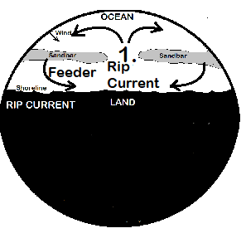

17.

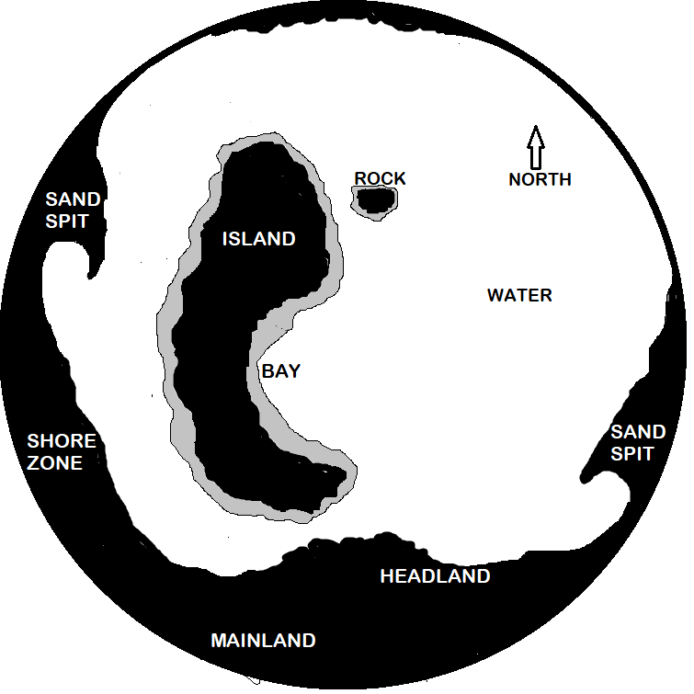

SHORE ZONE CURRENTS
Video link
https://youtu.be/PEg7RgmtN8Q

-Select presentation and performance expectations pages 1-4.
-Supplement with resource material. NGSS: ESS 2-2,2-4, 3-1; PS 1-2,3-5
-Create presentation & note taking copies using this page.
SHORE ZONE CURRENT LESSON (Air Pump Activity)
- Simulate eddy currents (back flow). Use adhesive gum for “rock” and “bay shoreline” barriers. Use glitter for “sand” and blue dye to trace current:
Pump: p. 3, 4B. Position outlet to fine tune bay backflow and to equally
separate current on “rock”. Air outlet is adjusted--partly submersed in water
for max current, no bubbles. Place transparency “kayak” (i.e fuselage p. 22
cut-out) in “bay”, add glitter and dye as needed to show Bernoulli’s principle.
2. Place “kayak” behind “rock” (refer to page 22). Observe, discuss movement.
3. Fast current erodes shore zone, transports sand, slows down and eventually
deposits sediments. Identify potential erosion and deposition features.
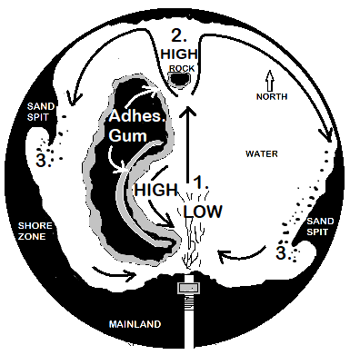

18.

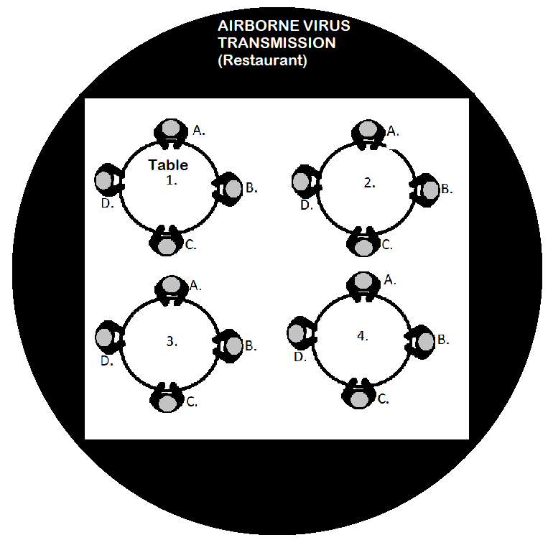

Video link
https://youtu.be/h7bdJbZC9UE

AIR CURRENTS
(INSIDE)

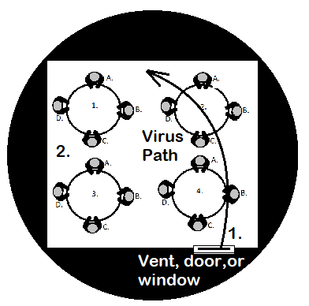
-Select presentation and performance expectations pages 1-4.
-Supplement with resource material. NGSS: LS1, LS 2-1
-Create presentation & note taking copies using this page.

INDOOR AIR CURRENT LESSON (Eyedropper)
- Simulate air flow movement in a room related to open door, window, and/or vents. Relate to airborne germs. Use red dye purged from eyedropper to show how airborne germs travel.
2. Place adhesive gum “barriers” at various locations to create a
variety of air currents in a room (i.e. use a spoon to draw a line
from one side to another and then add dye).

19.

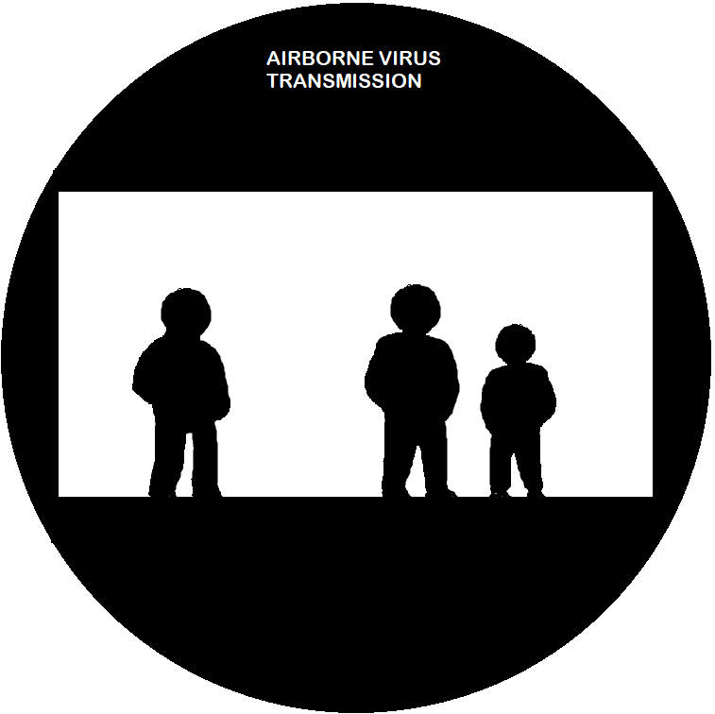

AIR CURRENTS
(OUTSIDE)

-Select presentation and performance expectations pages 1-4.
-Supplement with resource material. NGSS: LS1, LS 2-1
-Create presentation & note taking copies using this page.

OUTDOOR WIND LESSON (Eyedropper)
1.Simulate air flow movement outside related to wind. Relate to transmission of airborne germs. Use red dye purged from eyedropper to show movement from person to person.

2. Change “wind” direction. Highlight with red dye.
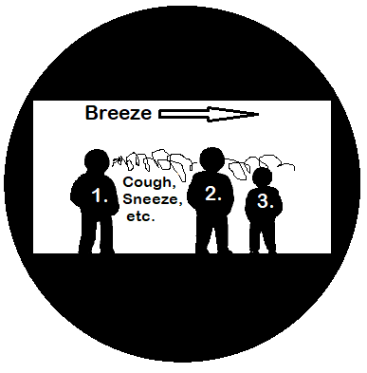

20.

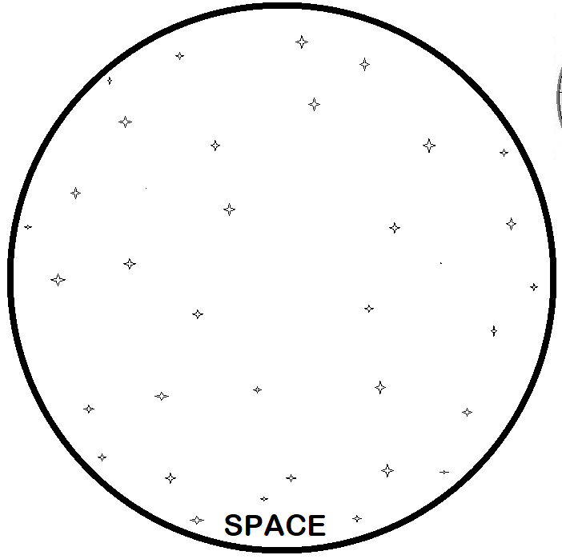

ORBIT,
GRAVITY

-Select presentation & performance expectations p.1.
-Supplement with resource material. NGSS: NGSS:
ESS 1-1 to 1-3, 3-1to 3-5, PS 2-4
-Create presentation & note taking copies this page.

ORBIT AND GRAVITY LESSON
Cut-out globe, etc. template(s). Suggestion: select a cut-out (right) and place under plate in center of space template. Add water. Create current on perimeter to move satellite (cut-out)
in orbit around the earth. Discuss objects moving in space around a gravitational field. Relate to
earth, solar system, black holes, etc.

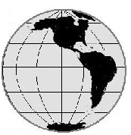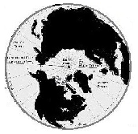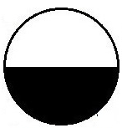

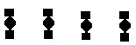

21.

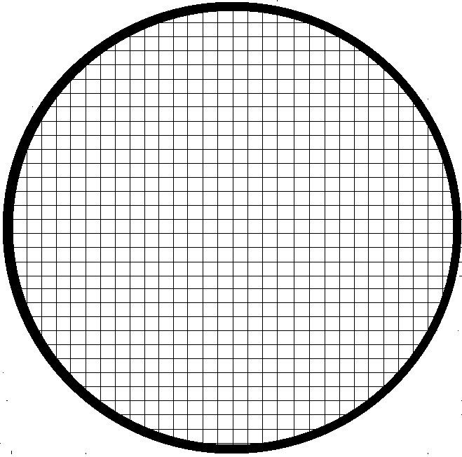

GRID

EXTENSIONS (refer to p.4)
1. Use grid for measurements like current direction and change of velocity (pressure) around different objects.
2.Make plastic cut-outs of continents--show drift.
3. Demonstrate high-low pressure river hydraulics using
kayak cut-out or glitter.
4. Create objects (i.e. wing)
that show pressure change (adhesive gum, clay, etc.).
5, Demonstrate common everyday air flow events.
6. Other________________
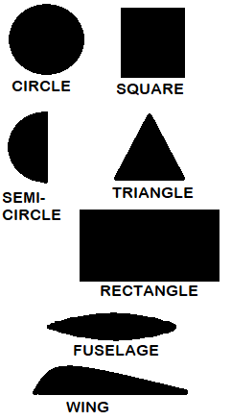

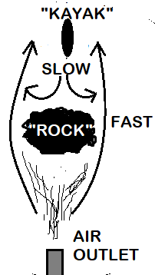
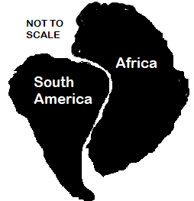

22.

